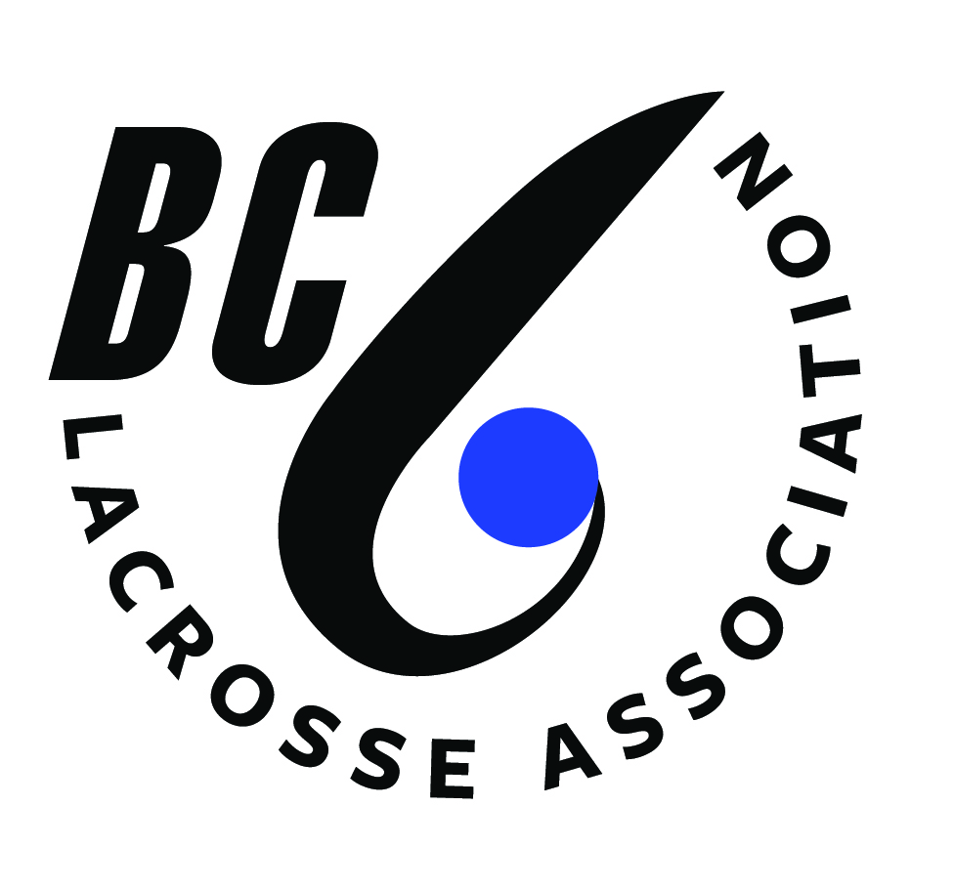

CHANGES TO THE
BC LACROSSE ASSOCIATION
MINOR DIRECTORATE OPERATING POLICY

MOTION(S) MADE BY:

Name: __________________________________________________________________

Position: ________________________________________________________________

Association/League/Club/Directorate: _________________________________________

Phone Number: _______________________ Email: _____________________________

- If you are amending a current regulation, or if you are adding a new motion, you must name the Regulation Number, and the point number.

- When amending a current regulation, you must first write the regulation as it currently reads. Then you write the motion as you would want it to read. Please complete one form for each motion you wish to put forth.
Please ensure changes are typed in RED font and any deletions typed in RED font and noted with the strikethrough marking. This ensures your proposed change is correctly identified and presented at the Special Session.

- A new space has been provided to give the rationale behind your motion.
- Also, please note there is a space to list the other current regulations your motion would affect. All of those affected regulations in all other Operating Policies would also have to be changed in the form of a motion.

ALL MOTIONS FOR THE BC LACROSSE ASSOCIATION MINOR DIRECTORATE SPECIAL SESSION MUST BE SUBMITTED
VIA E-Mail: debheard@bclacrosse.com

NO LATER THAN 4:00 PM ON WEDNESDAY, AUGUST 27, 2025.

CHANGES TO THE BC LACROSSE ASSOCIATION
MINOR DIRECTORATE OPERATING POLICIES

OPERATING POLICY: _________________________________________________
REGULATION NUMBER: _________ POINT NUMBER/LETTER: ____________

___ This is a new motion OR

___ The regulation currently reads as it appears on Page ____: (Please write out in full)

The amended regulation reads as follows:

The rationale for the motion:

This motion also affects the following (please name the Specific Operating Policies, Regulation Numbers, Page Numbers):

